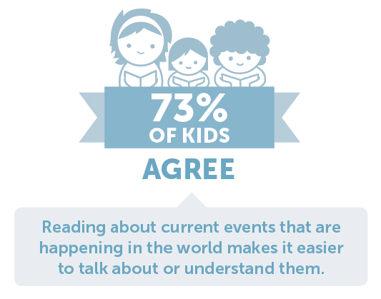
Dear Parents and Families:

Reading increases knowledge and vocabulary, lowers stress, and supports your child’s emotional growth. But perhaps the best benefit is the lasting bond you create with your child when you read with them.

Visit the Book Fair with your child to discover new books together!
Kids & Family Reading ReportTM: 7th Edition

Save the date!
Book Fair dates: May 10th -13th.

Shopping hours: 8:20am-8:50am, 9:20am-9:50am, 11:20am-11:40am and 12:20pm-12:40pm.

Special activities: We will be holding the fair on the front sidewalk just like in the fall!

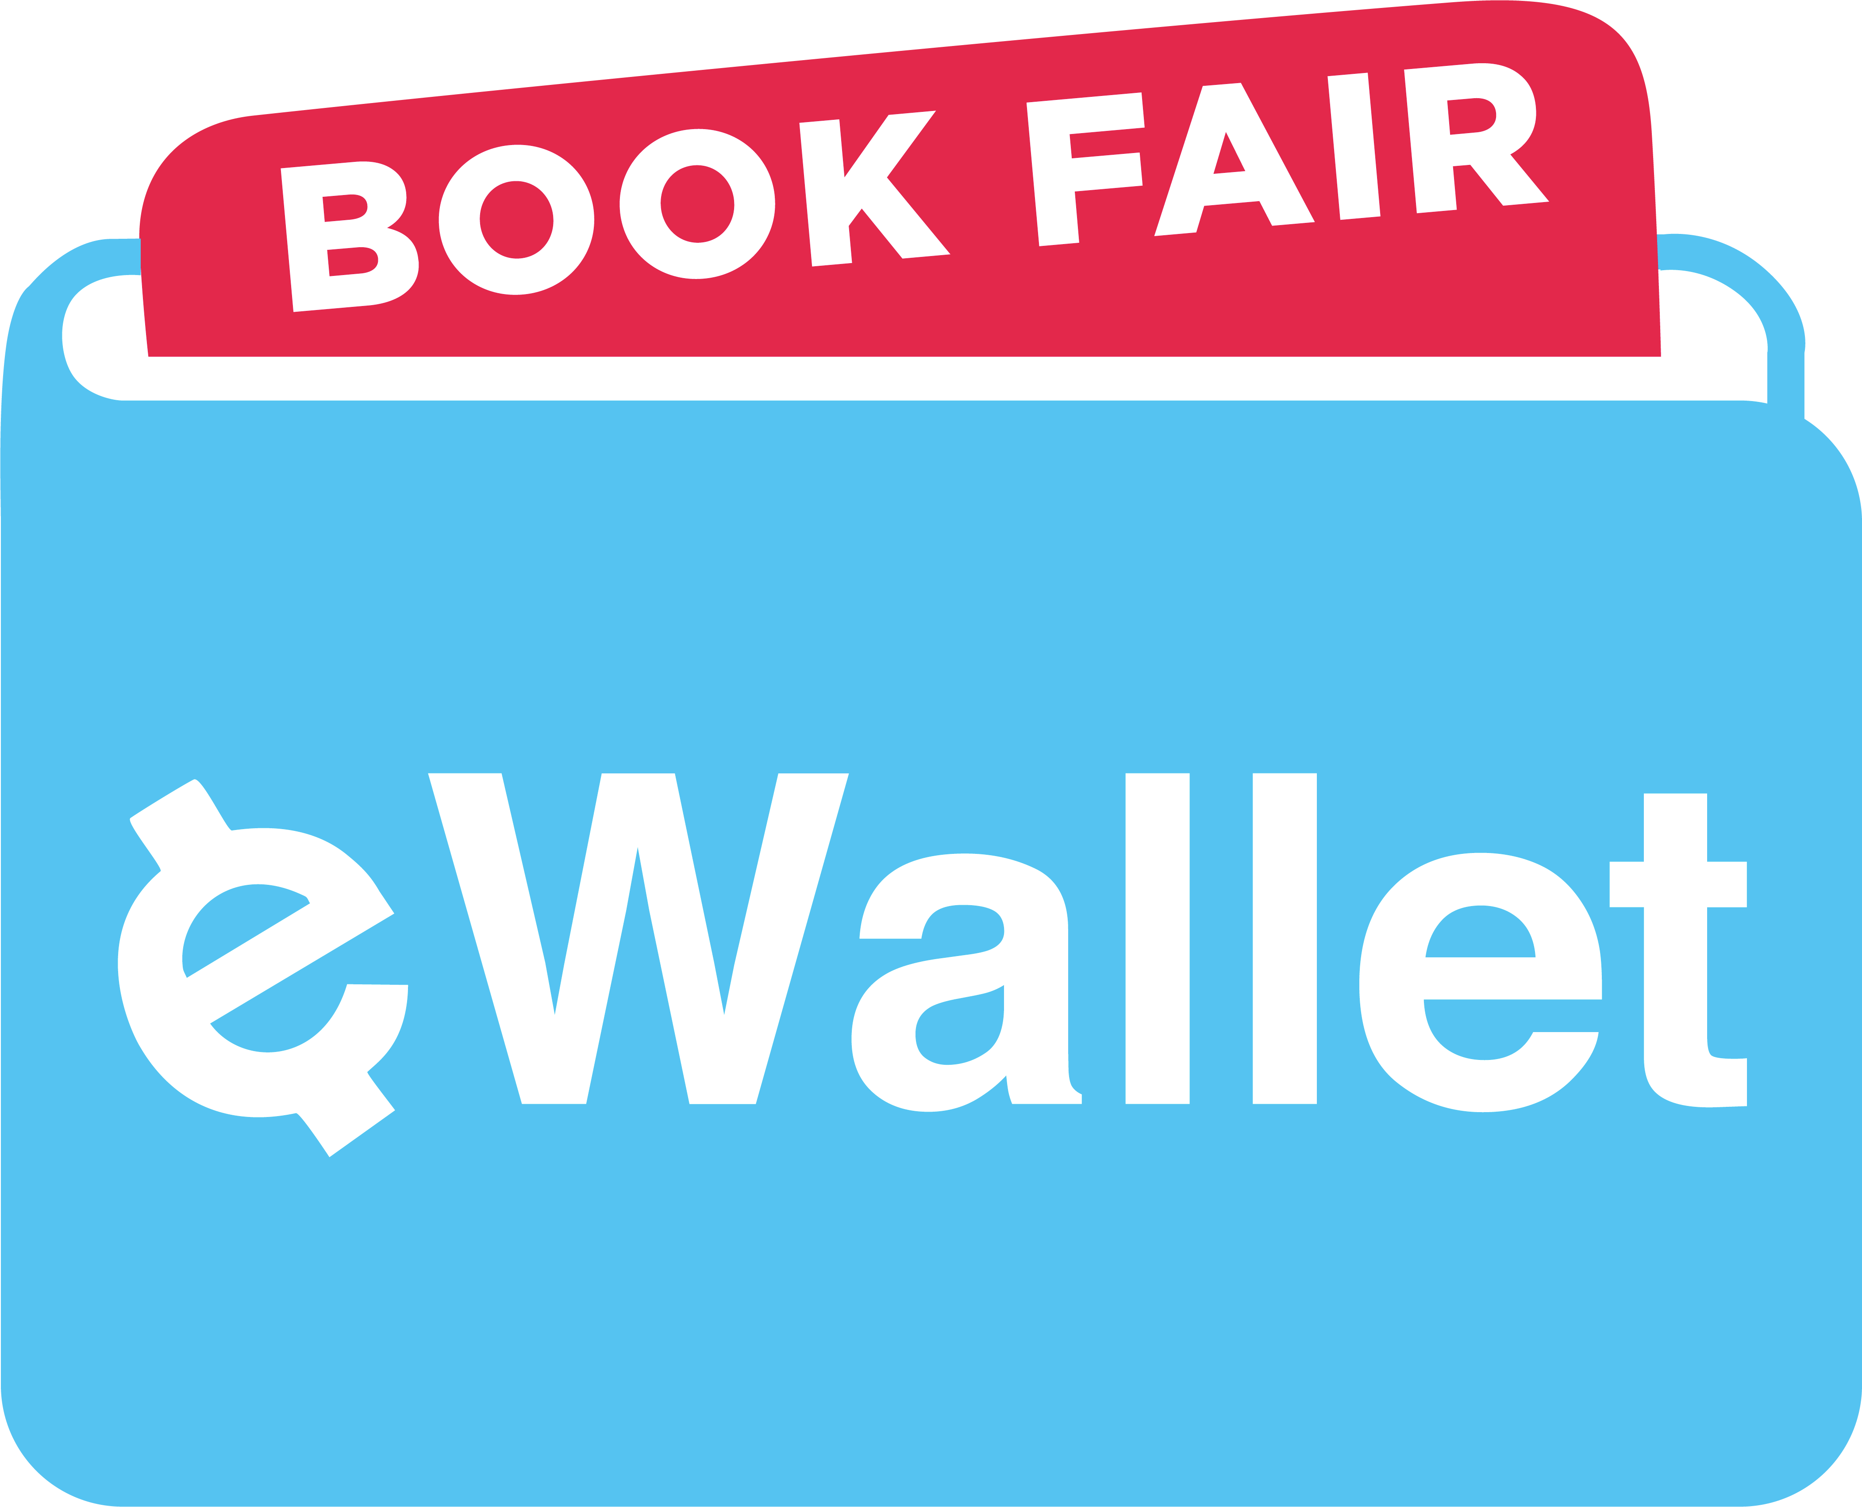
NEW at School and Online Shopping Options! With Book Fair eWallet, a safe and convenient digital payment account, your student can shop the Fair cash-free! And if you’re not able to attend the Fair, try our new online shopping option. We’ve partnered with The Scholastic Store™ to offer over 6,000 products that ship direct to your home (with free shipping on orders of $25 or more)! Visit our homepage to access eWallet or shop online.

We look forward to seeing you and your family at our Book Fair!

Sincerely,

Claire Prost
Clawson Preschool Coordinator.

