Bond Proposal – Steering Committee Meeting
September 23, 2020 – 7:00-8:30pm
Meeting Minutes
Meeting Format & Attendees
- The meeting began at 7:03pm
- The meeting was held virtually, via Google Meet
- A PowerPoint was shared with the group (available on the school website)
- Attendees
Tim Wilson, Jackie Johnston, James Stottlemyer, Brian Smilnak, Mary LeFevre, Joe Luther, Amy Baumer, Jennifer Tucker, Cindy Wycoff, Jenny Smolinski, Eric Stephan, Sarah Stevens, Christen Wilder, Claire Prost, Renay Swords, Amy Carpenter, Bianca Sines, Karen Abdella, Jennifer Pintek, Ken Stetson, Billy Shellenbarger, Kelly Horne, Katie McClure, Sophie Guerro, Jillian Liford, Rafal Mahmood, Scott Sarvello, Kelly Pearson, Michele Cawley, Najwa Bournias, Dyanne Hildebrant, Theodore Jaworski, Kimmi Carlesimo, Ted Verner, Heather Maurer, and Michael Harris

Welcome & Introductions

- On Tap Tonight – Superintendent Tim Wilson & Assistant Superintendent Jackie Johnston
  - Welcome and thank you for your participation
  - This committee is developing a bond plan recommendation to the School Board
  - We are targeting an August vote, which will mean we have some work to do to get a recommendation to the School Board by February
  - Goals of tonight: Everyone to walk away with a common understanding of the condition of the district and to gather input on future vision
- Warm-up - Amy Baumer, The Christman Company
  - Poll Everywhere exercises were conducted to engage the group and help everyone learn more about each other
NEEDS ASSESSMENT

- The Process – Joe Luther, The Christman Company
  - Architects, engineers, and estimators walked the four buildings (Kenwood, Schalm, Middle School, High School) and developed a list of work items
  - Stakeholder interviews were conducted with department heads, principals, teachers and other staff to discover how the buildings are being used, operationally, what is working well, and what can be improved
  - Based on the building walks and stakeholder interviews, over 200 work items were identified across the four schools
  - Initial cost estimates were completed for each work item
- Prioritization – Joe Luther, The Christman Company
  - An initial review and prioritization of the 200+ work items was completed as a starting point; this list of items will grow and the priorities will change as this group gives input on what is most important
  - General overview of the initial priority classifications – note these will change as the process evolves
    - Priority 1 – Minimum Immediate Requirements: must be completed to ensure the current buildings can remain operational for another 20+ years
    - Priority 2 – Improve & Modernize: Improvements and modernization of the facilities
    - Priority 3 – Potential Future Enhancements: to be developed as we start to analyze concepts
- Construction Funds – Joe Luther, The Christman Company
  - Based on a zero-mill increase bond approval, the district can raise approximately $50M
  - After factoring in technology, buses and other district needs, the construction budget is approximately $42.3M, including all fees and contingencies
- Building by Building Overview – Brian Smilnak, Wakely & Joe Luther, The Christman Company
  - A general overview of each school, classroom usage and the overall building utilization was reviewed
    - The Treasury Department suggests that districts target 85% utilization of their buildings
    - Clawson Schools are less than 50% utilization of existing buildings
  - Joe discussed the Priority 1 work items total cost per building and gave examples of items at each school that are needed
- Summary of Findings - Joe Luther, The Christman Company
  - The total for all initial priority 1 items across the four buildings (Baker has not yet been evaluated to this level of detail nor included here) is $43.9M
  - As stated earlier, the district will have approximately $42M for construction
  - The current Priority 1 list includes no operational improvements; these items would only cover the costs to extend the useful life of the current facilities

VISIONING & PRIORITATION STRATEGIES

- Review of school vision and mission statements – Amy Baumer, The Christman Company
  - These are important to keep in mind as this committee envisions what the district could look like over the next 20+ years
- Envisioning the Future Together - Amy Baumer, The Christman Company
  - The word collage generated by this group at the first meeting was reviewed (below) and compared to the mission statements highlighting their many common themes, including: collaboration, community, diversity/inclusion, future opportunities, growth small town, students and staff
- SWOT Analysis - Amy Baumer, The Christman Company
  - The committee participated in a Strengths, Weaknesses, Opportunities and Threats exercise; see supporting documents below

LOOKING AHEAD

- Key Milestones – Amy Baumer, The Christman Company
  - Milestones that will lead to an August vote were reviewed
  - An initial recommendation will be presented to the School Board in November, a final recommendation is needed by mid-February
  - The work of this committee will be an important component to the ultimate School Board bond resolution, planned for March
- Workgroups - Amy Baumer, The Christman Company
  - Dialogue needs to happen at a micro level and smaller workgroups that target the seven Areas of Focus will facilitate this
  - A core team member will sponsor the workgroups and support their progress
  - All committee members are asked to use Signup Genius to make selections for their workgroup preferences

CLOSING

- Recap of Key Highlights & Closing – Superintendent Tim Wilson
  - The group was thanked again for their commitment to the district and work on this committee
  - The heaviest lifting in this process is in the next couple months and then the work will taper off
  - Jamie Stottlemyer will no longer be able to serve as part-time Facilities Director for Clawson due to his responsibilities in Ferndale, effective January 1, 2021
  - The next meeting is Wednesday, October 07, 2020 at 7pm
  - There will be a Community Forum on October 14, 2020 at 7:30pm, while the group is welcome to attend, no work for this group is needed; the forum will bring the community up to speed and give them an opportunity to share input
- Contact Co-Chairs or superintendent with any questions
  - Jamie Stottlemyer, James.Stottlemyer@clawsonschools.org, 248-701-4630
  - Jackie Johnston, Jackie.Johnston@clawsonschools.org, 248-655-4411
- The meeting closed at 8:28pm

SWOT EXERCISE

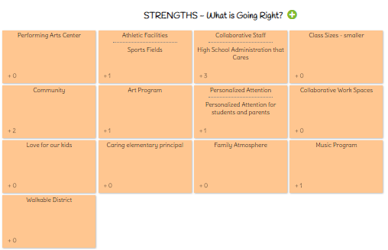

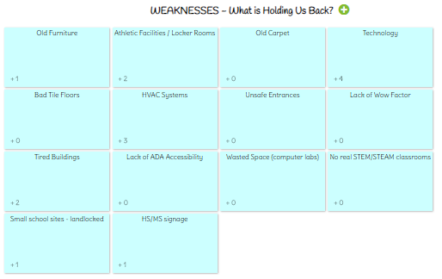
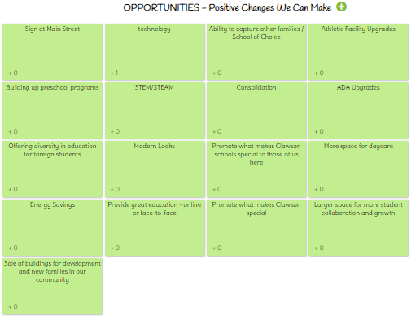

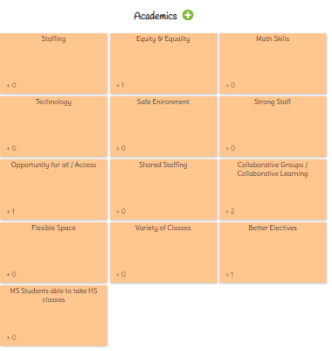
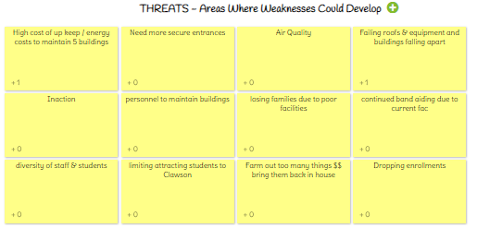
AREAS OF FOCUS
