The FROG Log
Jan.10, 2017
Events:
January 9 | - Popcorn Sale this week, $.50 per bag. Orders due by Thursday.
January 10
January 11
January 12 | - Popcorn orders are due.
January 13 | - Popcorn Day!!
January 16 | - NO SCHOOL-Martin Luther King Jr. Day
January 17
January 18
January 19 | - Detroit Pistons Assembly
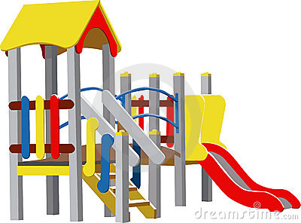
Playgrounds
Please remember that the playgrounds are closed to students both before and after school each day. Before school, all students should line up at their assigned door. Kindergarteners should line up at their door too (with their parents). If the playground is too tempting for your kindergartener, please wait on the sidewalk. All students should leave for home by 3:15 (second bell).

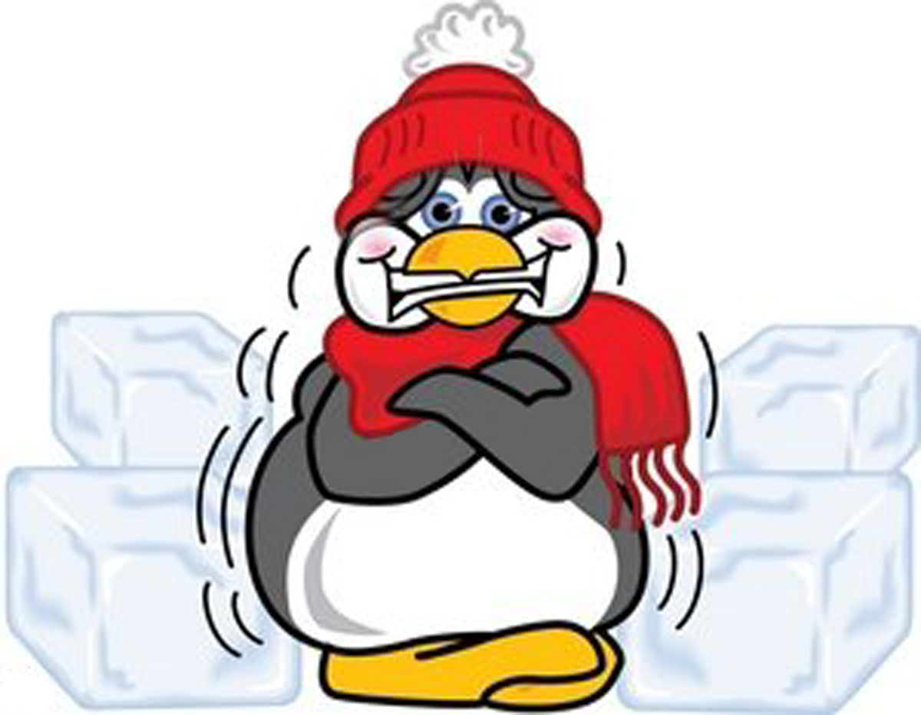
Cold Weather….BRR!!
Please remember, we do go outside for recess! Please send your child dressed for outdoor play. This means snow/ski pants, snow boots, gloves, hat/hood, and warm coats. Boots and ski pants are even recommended for 3-5th graders! Students without boots will be asked to stay on the sidewalk and blacktop. Students will also need a pair of shoes to change into (these can be left at school). We will go outside if the temperature is 10 degrees or higher (we use the “feels like temperature”).

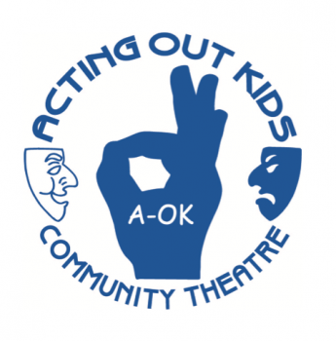
New After School Club
Acting Out Kids (AOK) will be starting an after school drama class at Kenwood for 3rd-5th graders. The first class will be January 24. To register, send an email to ActingOutKids@yahoo.com A flyer is included in this email.

Life Skill of the Month:
Examples:
- If you find something, look for the owner or turn it in to an adult.
- Admit to mistakes, even when you know there are consequences.
- Tell the truth all the time.
- Correct misinformation you hear about others and stop the gossip.
- Share your true feelings in a tactful way.
Truthfulness: To be honest about events and feelings

