Thursday, March 23, 2017
Spring Begins!
Happy Birthday to: Bianca Best

MS Wrestling has a meet today at home with Pierce MS at 4:00

MS Swim practice today at Lamphere. The bus leaves at 3:15

Chess Club meets today after school in the Media Center at 2:45-3:45

Any7th or 8th grade girl interested in playing Softball, please attend an informal meeting on Friday, March 24th in Ms. Stanton’s room immediately after school.

7th grade Chicago trip roommate selection forms and Insurance forms are due to Mrs. Nagy ASAP!
8th grade Cedar Point permission slips and money are to be given to Mrs. Nagy in room 216. There is limited seating and availability will be on a first come-first serve basis.
NJHS continues their hot chocolate sales after school on Thursdays until the end of March. Come by and see them in the lobby by the counseling office until 3. $1.00 a cup with or without marshmallows.
SCHOLAR’S CLUB continues. Scholars will be open every Tuesday, Wednesday, and Thursday, when there are full days of school, from 2:45-4:15 pm. This is a great place for students to get help with homework. Middle school students will meet in the MS Computer lab #110 and high school in their media center. Students wishing to attend Scholars Club after school must have a CURRENT contract signed by a parent on file. A new one is required for each school year. They are available in Scholars Club and in the main office.
Parents now have the ability to deposit money directly in to their child’s MiStar lunch account. Log on to Parent Connection and choose – Cafeteria – Online Food Service Program.
Parents, we would like to remind you that our school continues to collect BOX TOPS FOR EDUCATION. Please clip them out and send them in to our school.
Sports News:
MS Wrestling meet today at home with Pierce MS @ 4 in the MS gym
**Students - Please check the lost and found across from the cafeteria and counseling office for items that may be yours.
MARCH
3/23/17 MS Wrestling Meet home with Pierce MS 4:00

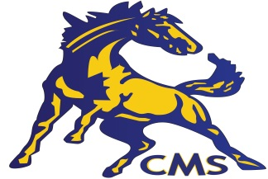GOOOOOOOOOO MUSTANGS!

